1: Access the Below link

<https://www.anaconda.com/products/individual>

2: Scroll to the bottom of the screen and you can see the below image, based on you system setup please install windows.max or linux .

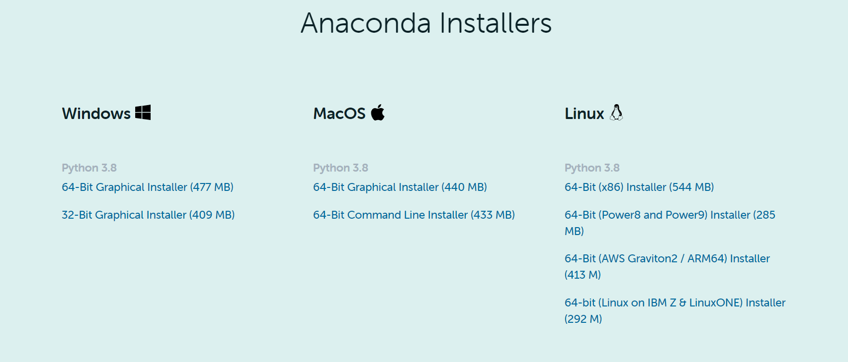

3:Once the Installation is complete , you can see the anaconda command promt in start option and launch anaconda command promt.

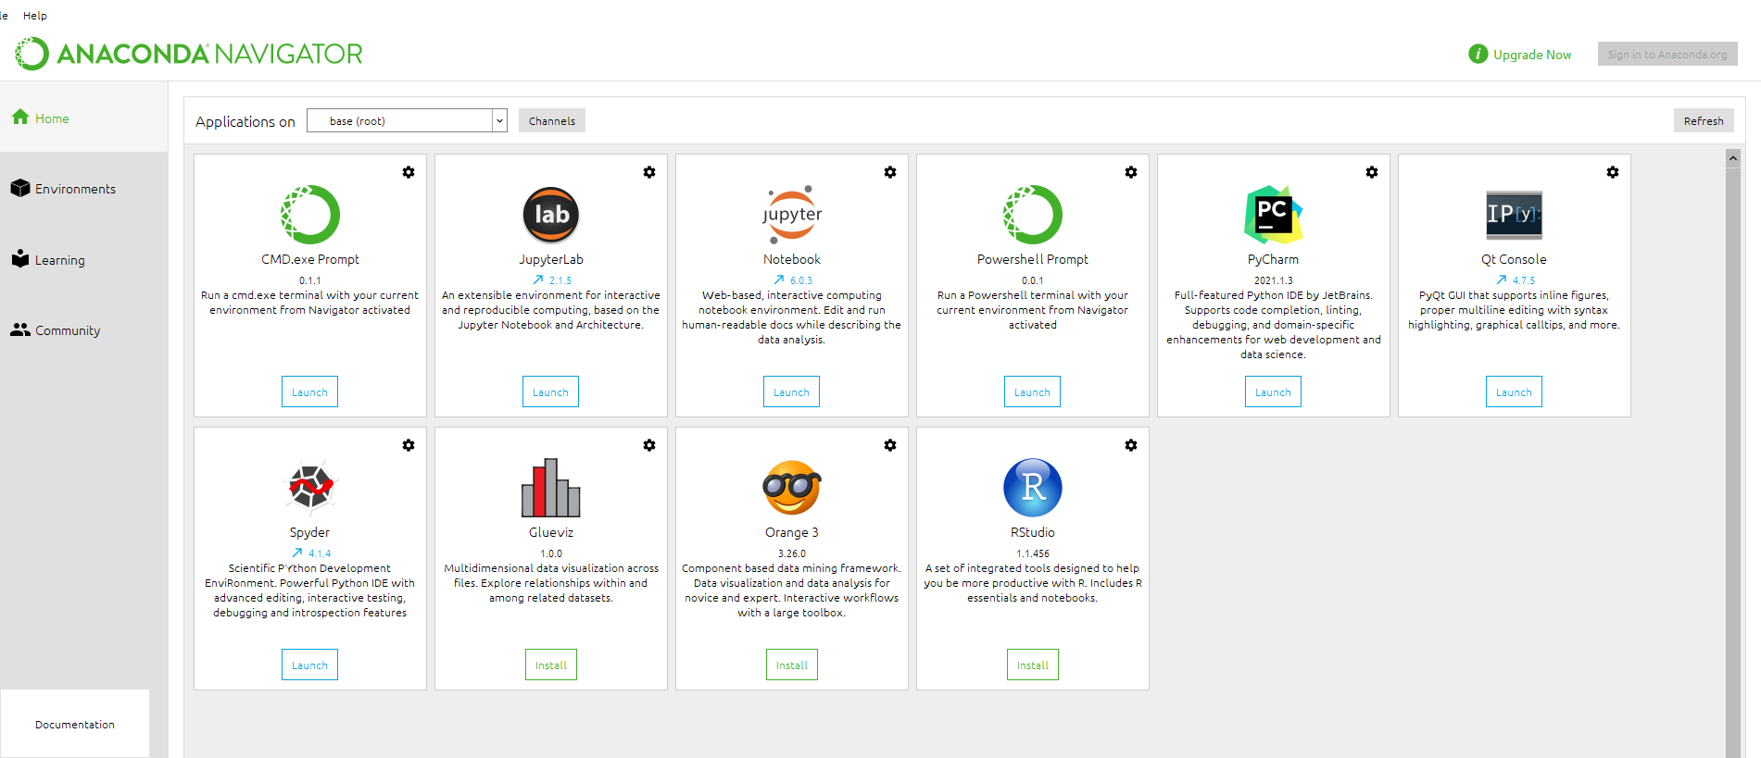

4: Launch Jupyter notebook where we will start learning python together.

